**LAPORAN HASIL PRAKTIKUM**

**MATA KULIAH :**

**TEKNIK PEMROGRAMAN – PERTEMUAN 9**

Disusun Oleh :

|  |  |  |
| --- | --- | --- |
| **NIM** | **NAMA** | **KELAS** |
| 221524061 | Thoriq Muhammad Fadhli | 1B |

**D4 TEKNIK INFORMATIKA**

**POLITEKNIK NEGERI BANDUNG**

**2023**

**DAFTAR ISI**

1. Penerapan Generic Programming 3

A. ExpenseController.java 3

B. ExpenseCategory 5

C. ExpenseRepo.java 5

D. ExpenseService.java 7

2. Solusi dari masalah yang dihadapi 8

3. Nama teman yang membantu 8

# Penerapan Generic Programming

## ExpenseController.java

Enumeration

return ResponseEntity.status(HttpStatus.NO_CONTENT).build();

return ResponseEntity.status(HttpStatus.CREATED).build();

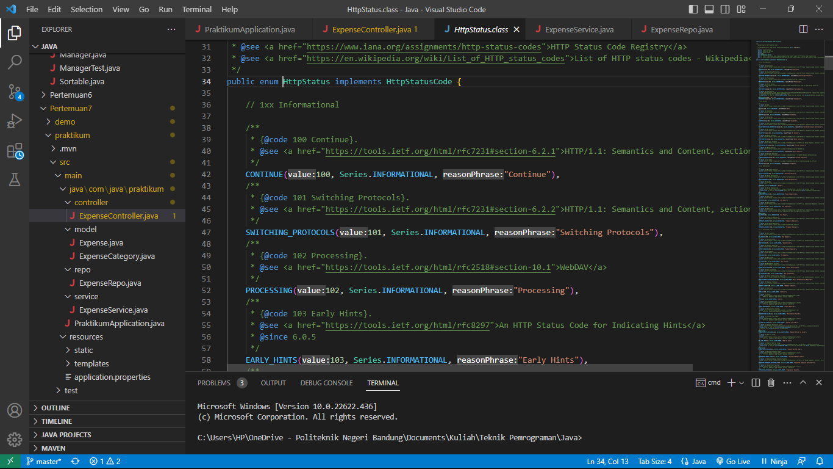

Generic Class

public ResponseEntity<Object> updateExpense(@RequestBody Expense expense)

return ResponseEntity.ok().build();

public ResponseEntity<Object> deleteExpense(@PathVariable String id)

public ResponseEntity<Expense> getExpenseByName(@PathVariable String name)

public ResponseEntity<List<Expense>> getAllExpense()

return ResponseEntity.ok(expenseService.getExpenseByName(name));

return ResponseEntity.ok(expenseService.getAllExpense());

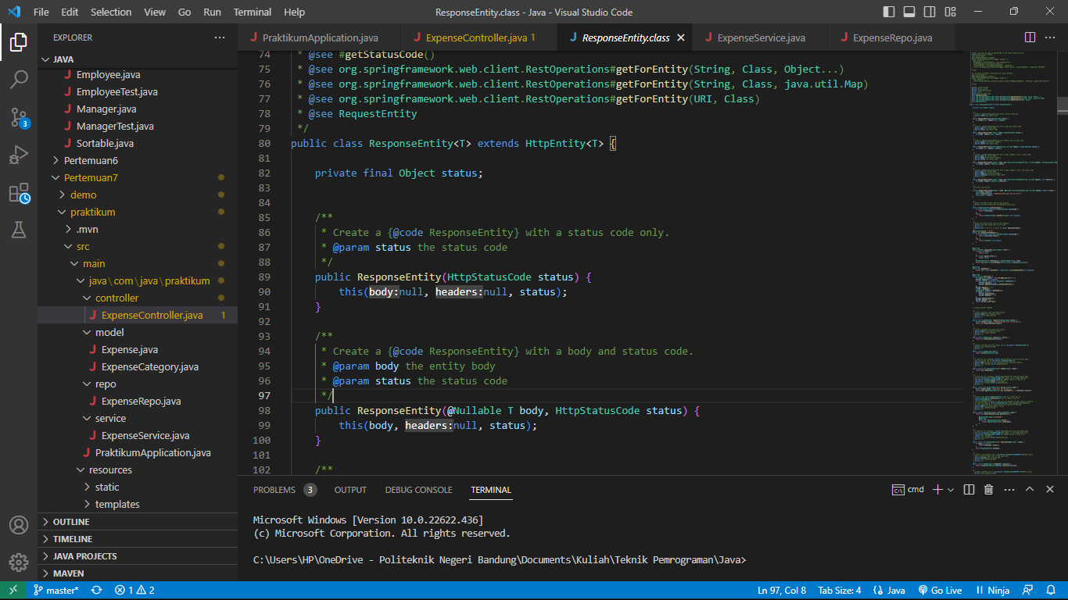

## ExpenseCategory

Enumeration

public enum ExpenseCategory {

    ENTERTAINMENT, GROCERIES, RESTAURANT, UTILITIES, MISC

}

## ExpenseRepo.java

Generic Class

public interface ExpenseRepo extends MongoRepository<Expense, String> {

    @Query("{'name': ?0}")

    Optional<Expense> findByName(String name);

}

## ExpenseService.java

Generic Class

expenseRepository.insert(expense);

expenseRepository.findById(expense.getId())

public List<Expense> getAllExpense() {

        return expenseRepository.findAll();

    }

return expenseRepository.findByName(name)

expenseRepository.deleteById(id);

# Solusi dari masalah yang dihadapi

Searching, Googling, Memahami lebih cermat.

# Nama teman yang membantu

1. Najib Alimudin Fajri